Linux Programming
lab-5

name:k.bhavesh
reg.no:17MIS1079

Exercise 1:

Code:
in the given code there is a compilation error i.e, intmain , we can’t proceed further with this error so cange it to int main.
#include <stdio.h>
/* Print the sum of the integers from 1 to 1000 */
int main(int argc, char **argv)
{
int i;
int sum; sum = 0;
for(i = 0; i -= 1000; i++)
{ sum += i; }
printf("%d\n", sum);
return 0;
}

Output:

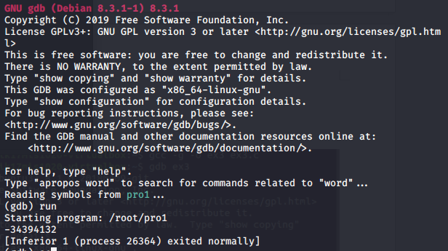
By seeing the above output we can say that the program is not for displaying sum of first 1000 num bers. So there are some errors with the code , we can find out by debugging.

Go set a break point at main function and check for all the lines by giving next. Check the data values each line.

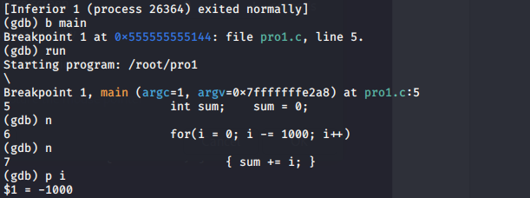

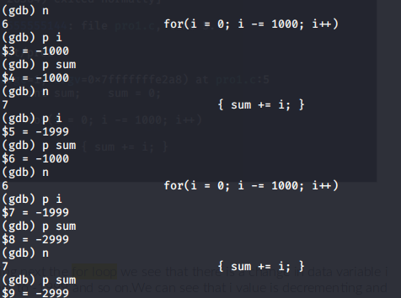

So if we observe, after giving next the for loop we see that there is a change in data variable i from 0 to -1000 and further to -1999 and so on.We can see that i value is decrementing and sum value is added with the i.Therefore there is no error in the next of for loop line i.e, sum=sum+i. So we can say that there is an error in the for loop line.

for(i = 0; i -= 1000; i++)

if we cahnge the for loop as

for(i = 0; i <= 1000; i++) it works.
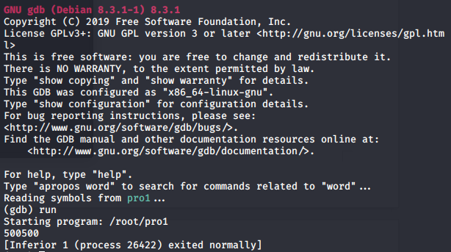

(1000*(1000+1))/2 = 500500

Exercise 2:

Code:

#include<stdio.h>

int main()
{
char *s = “Goal”;
char *t = “Home”;
while(*s++ = *t++)
printf(*s);
return 0;
}

As you see there are warnings , but an executable is still created. So lets execute it with gdb and find out the bugs.
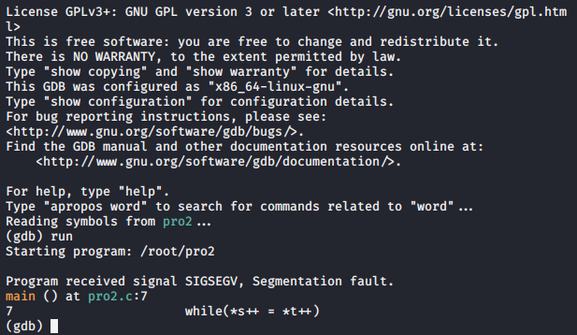
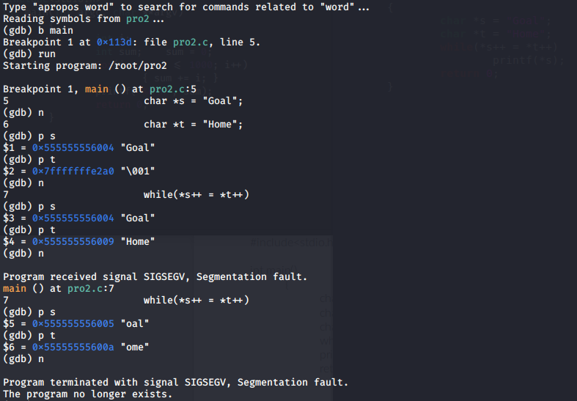

Gdb shows the error in 7th line i.e, in the while loop. So let’s understabd the while loop first. The while loop is matching the two string literals(s and t ) and changing s to t. This modification can’t be done without causing a segmentation fault as they both are declared as string literals. So we need to change first string to char array. This way, the elements of the first string can be modified without causing a segmentation fault.

char arr[] = "Goal";
char *s = arr;

Now, string s can be morphed into string t via the while loop without faults. The loop doesn’t need a body, and just to check if the transformation has been done properly, we print the array. So, our modified code should look like :

#include<stdio.h>

int main()
{
char arr[] = "Goal";
char *s = arr;
char *t = "Home";
while(*s++ = *t++);
printf("%s", arr);
return 0;
}

